“Tales from Freight TAILS”: Edition 1
ARTICLE 1: Freight TAILS…The Essentials
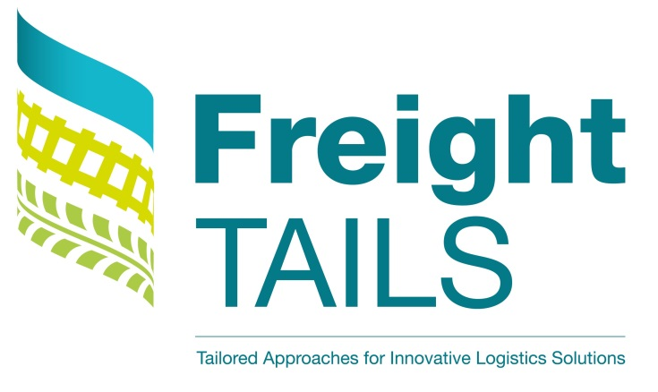
What? Freight TAILS is a project pulling together 10 cities from across Europe all with an interest in reducing the impact of urban freight movements. This project is funded by the European Regional Development Fund, through the URBACT III Action Planning Networks programme. www.urbact.eu.
Why? European city authorities are responding to the increasing impacts of freight movements in their cities on issues such as air quality, traffic congestion, and economic competitiveness. Freight TAILS will enable 10 cities to come together, exchange and learn from each other’s experiences.
How? Each partner city will locally work with their urban freight stakeholders (in an ‘URBACT Local Group’) to develop an Integrated Action Plan together, to reduce the impact of their urban freight. Transnationally, partners will meet every 3 months to share knowledge, learn lessons and consider the relationship between urban freight and the six transnational themes of: stakeholders, data, integration, regulation & enforcement, voluntary behaviour change, procurement.
Who?
Lead Partner:
- Westminster City Council (acting as accountable body for Cross River Partnership). www.crossriverpartnership.org Contact: Charlotte Knell. E: cknell1@westminster.gov.uk.
Project Partners:
- City of Maastricht. www.gemeentemaastricht.nl
Contact: Francoise van den Broek.
E: francoise.vandenbroek@maastricht-bereikbaar.nl

- Municipality of Parma. www.comune.parma.it
Contact: Patrizia Marani.
E: p.marani@comune.parma.it

- Municipality of Suceava. www.primariasv.ro
Contact: Dan Dura.
E: dandura@primariasv.ro

- Municipality of Gdynia. www.gdynia.pl
Contact: Alicija Pawłowska.
E: a.pawlowska@zdiz.gdynia.pl

- City of Tallinn. www.tallinn.ee
Contact: Jaagup Ainsalu.
E: Jaagup.Ainsalu@tallinnlv.ee

- City of Split. www.split.hr
Contact: Ela Žižić.
E: ela.zizic@split.hr

- La Rochelle Urban Community. www.agglo-larochelle.fr
Contact: Matthieu GRAINDORGE.
E: matthieu.graindorge@agglo-larochelle.fr

- Brussels Mobility. www.bruxellesmobilite.irisnet.be
Contact: Charlotte de Broux.
E: cdebroux@sprb.brussels

- Umeå Municipality. www.umea.se/umeakommun
- Contact: Stig Lundgren.
E: stig.lundgren@umea.se
When? This is a two year project running between May 2016 – May 2018.
How do I find out more? Look at our Freight TAILS webpage, and follow us on twitter: @freight_tails.
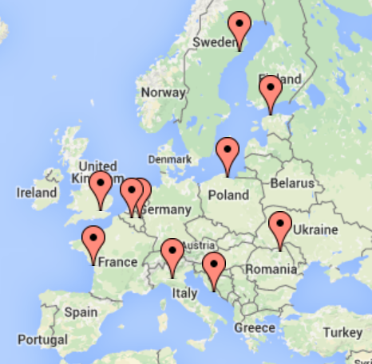
Freight TAILS partner cities.
ARTICLE 2: A flying start for Freight TAILS in Suceava, Romania
The Freight TAILS kick-off meeting of European partners was superbly hosted by our partner City of Suceava, Romania on 27-28 June 2016. With over 120 organisations already involved in local Freight TAILS groups across Europe, this first transnational meeting focussed on how to attract, and work with more diverse stakeholders all of whom have an interest in urban freight.
Many local Suceava stakeholders were present at the meeting, and we had the opportunity of interviewing representatives of the city authorities transport department, and tourism department; the environmental protection agency; a local newspaper; and a local car dealership.
Following these local stakeholder interviews we were treated to a tour of the city centre and commercial zone, to see first-hand the urban freight management issues and discuss the potential solutions.
Ion Lungu Mayor of Suceava City welcome Freight TAILS partners to the Phase 2 Kick off meeting 27-28 June 2016.

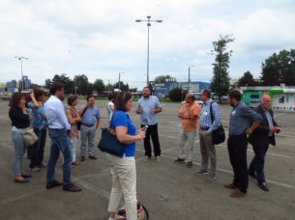
Freight TAILS Suceava partner Dan Dura explains the urban freight management problem and potential solutions in the city’s commercial zone, 27 June 2016.
ARTICLE 3: Freight TAILS Focus … Stakeholders
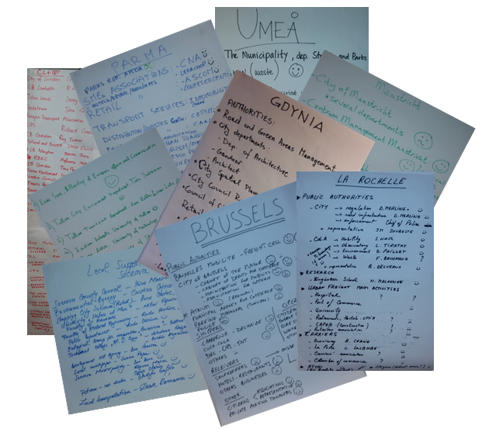
Flipcharts produced at the Freight TAILS Transnational meeting in Suceava 27-28 June 2016.
Freight TAILS partners will contribute their experiences and knowledge to papers on the relationship between urban freight management and six transnational themes: stakeholders, data, integration, regulation & enforcement, voluntary behaviour change, and procurement.
‘Stakeholders’ was the focus of our first transnational meeting 27-28 June in Suceava. In advance of the meeting each partner interviewed members of their URBACT local groups. Here is a flavour of the feedback:
“Logistics is beginning to be recognised as a priority” University, Tallinn
The challenge is: “Who is willing to pay for service?” UCC Operator Maastricht
“Opportunities for mixed transport – buses could transport goods”. University, La Rochelle
“We want to be part of the solution, not of the problem.” Logistics Provider, London

A number of interesting discussion points were raised in Suceava, based on these stakeholder interviews:
- Best practices can be adopted, but need to be adapted to different cultural, economic and social local contexts.
- Logistics and supply chain management is very complex, and there may be a need for increased knowledge and understanding within and across city authorities, and other stakeholders, as a first step in addressing the impact of urban freight.
- Stakeholders need a common and precise vocabulary, to jointly address urban freight management.
- The success of one stakeholder’s urban freight management actions may well be reliant upon another stakeholder. For example, city regulations are often required to be enforced by local police.
- Another factor in successful urban freight management solutions is the personality of individuals involved, and the relationships that are built between individuals.
A ‘Freight TAILS Focus on Stakeholders’ paper will be finalised in the Autumn 2016. Please contact the Freight TAILS project co-ordinator: Charlotte Knell cknell1@westminster.gov.uk if you would like to feed in your thoughts on the topic of urban freight management and ‘stakeholders’.
Future Freight TAILS Focus … Data
The next Freight TAILS theme to be discussed by URBACT local groups is ‘Data’, which will be the thematic focus of our next Freight TAILS transnational meeting in Umeå, Sweden in October 2016. Key questions for consideration are:
- What data do we have / not have
- Where does or could the data come from?
- What data is useful for what purpose?
- How do we get and use the data – can we share the data?
- What data collection is realistic and sustainable?
- What data beyond ‘urban freight management data’ is useful?
If you would like to feed in your thoughts on the topic of urban freight management and ‘data’, please contact the Freight TAILS project co-ordinator: Charlotte Knell (cknell1@westminster.gov.uk).

ARTICLE 4: News from Freight TAILS and Beyond…
Gathering knowledge and experience from the Freight TAILS partners, our Lead Expert, Philip Stein has fed into the preparation of DG MOVE’s Non-Binding Guidance Documents to support Urban Logistics policy making and implementation. Philip will continue to represent Freight TAILS in the development of this work.
Freight TAILS is linking to the EU Urban Agenda programme’s Air Quality Partnership, providing knowledge and experience on air quality actions from across Europe.
Freight TAILS partner Gdynia will be hosting the CIVITAS Forum 2016, from 28-30 September 2016. Registration is now open.

ARTICLE 5: A bit of Freight Fun!
Take our Freight TAILS quiz to find out how much you know about our partner cities:
Question 1:
In which Freight TAILS city was this photo taken, and what does it say? 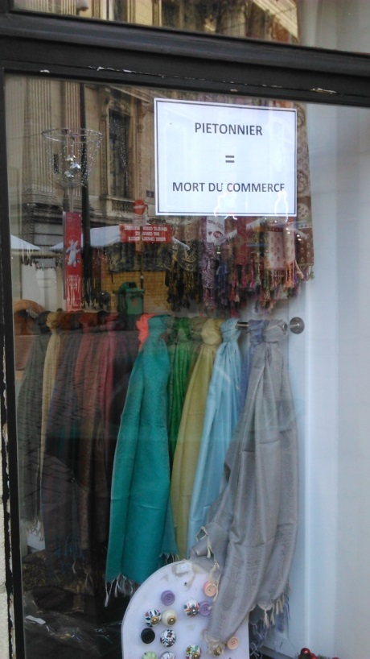

Question 2:
In which Freight TAILS city is this delivery and servicing activity taking place?

Question 3:
281,000 delivery and servicing vehicles are in use every day in which Freight TAILS city?
Question 4:
Which Freight TAILS city is this?
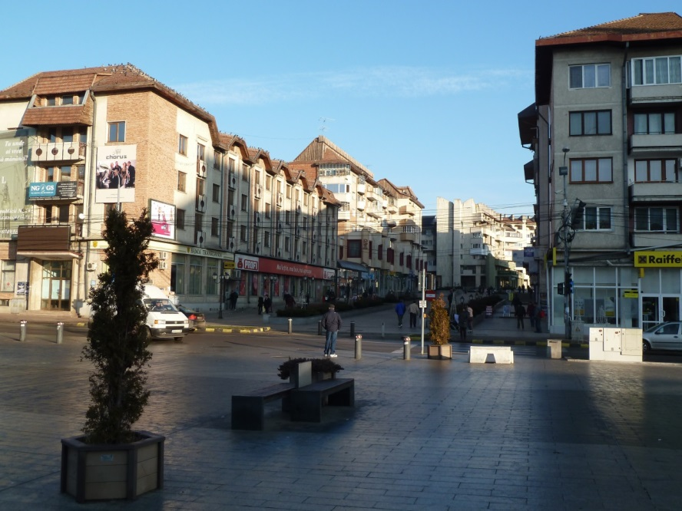
Question 5:
Which Freight TAILS city is this?
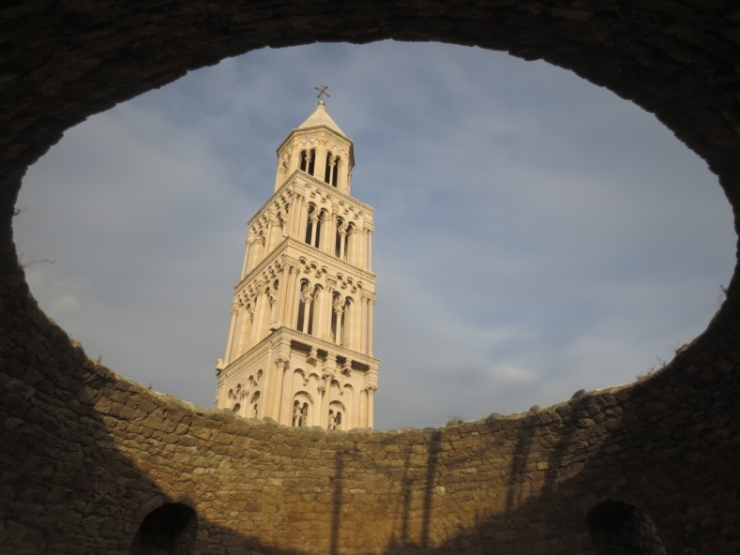

Question 6: Which Freight TAILS city is this?
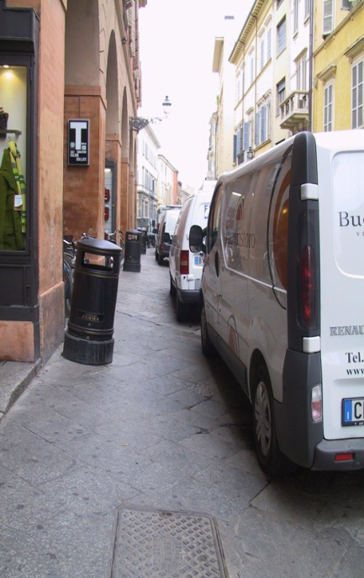
Question 7:
In which Freight TAILS city was project Lead Expert Philip wearing this hat, and why?
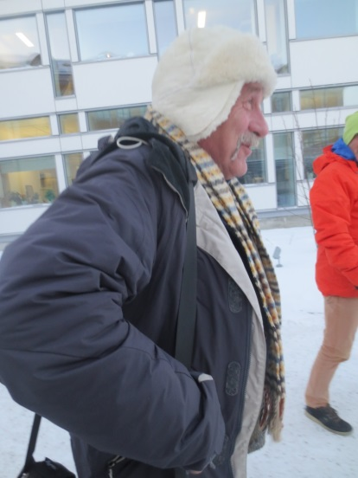
Answers:
1. Brussels – Pedestrianisation = the death of commerce. 2. Maastricht. 3. London.
4. Suceava. 5. Split. 6. Parma. 7. Umeå – at the time of visiting it was -25C.

Need to add URBACT and EU logos.
END

Outline of ‘Tales from Freight TAILS: Edition 2’ to be sent out September 2017:
A focus on the Freight TAILS partners – a short article with partner logo and suitable image, outlining the focus of each partner’s IAP.

Outline of ‘Tales from Freight TAILS: Edition 3’ to be sent out November 2017:

